

Installation / User Manual
APsystems ECU-RS

Energy Communication Unit (ECU)

Version: 1

© All Rights Reserved

Rev 1.0
Table of Contents

Introduction 2
Interface Explanation 3
Interface Layout 3
Reset 3
Power Connection Port 3
Antenna 3
LED1 4
LED2 4
Hardware Installation 5
Preparation 5
Selecting an Installation Location for the ECU 5
Cable Connections 6
Power Up ECU 6
Antenna Up ECU 6
Technical Data 8

Introduction

The APsystems Energy Communication Unit (ECU) is the information gateway for our microinverters. The unit collects module performance data from
each individual microinverter and transfers this information to an Internet database in real time, requiring only a single data and power cable. Through the APsystems Energy Monitoring and Analysis software, the ECU gives you precise analysis of each microinverter and module in your solar installation from any
web-connected device. The ECU’s integrated http webserver offers the simplest and most flexible network integration of any data logger on the market. The user-friendly browser-based interface lets you access your solar array in seconds.

Features
- Collects individual module and microinverter statistics
- Communicates in real time
- Requires no additional wiring

The APsystems Microinverter is used in utility-interactive grid-tied
applications, and is made up of three key elements:

- APsystems Microinverter
- APsystems Energy Communication Unit (ECU)
- APsystems Switch (APSwitch)
Android-based monitoring and analysis system
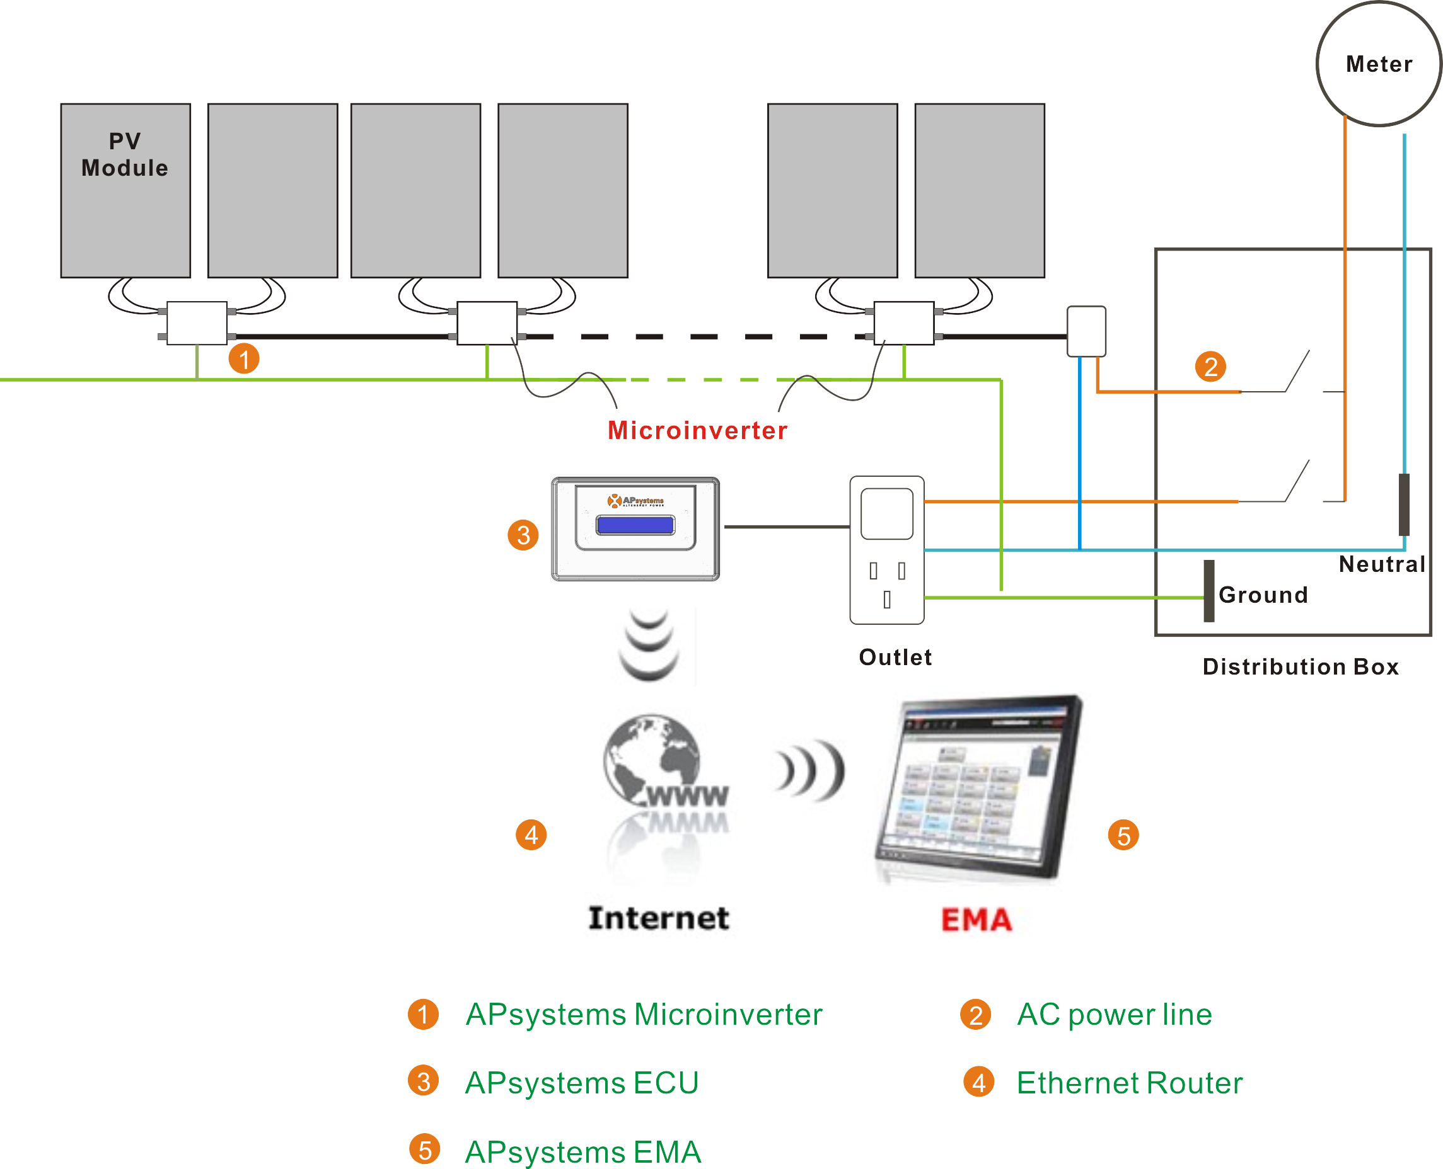 Figure 1

Interface Explanation

Interface Layout
The ECU interface includes, from left to right, are Reset,power
connection port,and antenna.

Power Connection Port RS232 Serial port Network port USB interface Reset
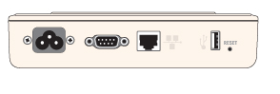 Figure 2

Reset
Press the Reset button for three seconds or longer, and the ECU will
automatically return to the default settings.


NOTE: The wireless password will be changed to ‘88888888’.

Power Connection Port
The power connection port connects power through the power line.

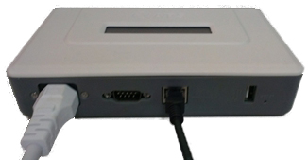 Figure 3

Antenna
All Data is obtained through the Antenna.

Interface Explanation

LED1
When the ECU to enable, LED1 light.

LED2
When the ECU does not add microinverter’s UID, LED2 light.

Hardware Installation

Preparation
Make sure you have the following components ready before
beginning to install the ECU:
- A dedicated standard AC electrical outlet (located
electrically as close to the array as is possible).
- An android phone with APSwitch.

Selecting an Installation Location for the ECU
- Choose a location that is electrically as close to the array as
possible – preferably a dedicated outlet installed
directly to the solar array’s sub-panel.
- The ECU is NOT rated for outdoor use, so if installing
outdoors near a junction box or breaker panel, make
sure you enclose it in an appropriate weatherproof
NEMA electrical box.

- Using a Wall Mount
When mounting the ECU to a wall, make sure to select a
cool, dry indoor location.
- Depending on the wall surface you are mounting the
ECU to, use either two (2) #8 drywall screws or wall
anchors, installed 130 mm apart. The drywall screws
and wall anchors are NOT included in the ECU kit.

- Align and slide the ECU onto the mounting screws.
130mm
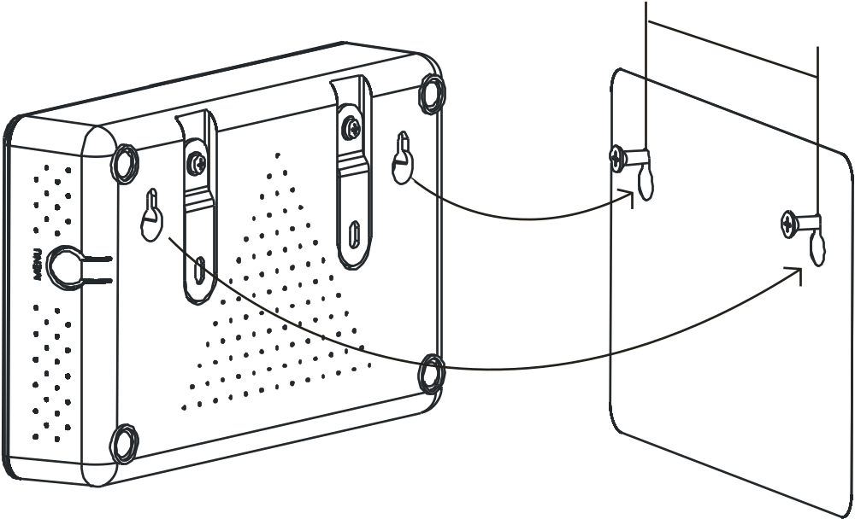 Figure 6

Hardware InstrallationHardware Installation

Cable Connections
Power Connection Port Network port
Figure 7

- Connect the supplied power cable to the power
connection port on the bottom of the ECU.
- Install the antenna in the corresponding position

Power Up ECU
- Make sure the adapter is properly connected to the
power port on the bottom of the ECU.
- Plug the power cable into a dedicated standard AC
electrical outlet.

Antenna Up ECU
- Make sure the antenna is properly connected to corresponding position on the bottom of the ECU.

Technical Data

Model: ECU-RS
Version: 1
Communication Interface
Integrated Wi-Fi | 802.11g/n
Antenna | Standard
Power Requirements
AC Adapter | 110~240 VAC, 50~60 Hz 5V 2A
Power Consumption | 2.5 W
Mechanical Data
Dimensions (W×H×D) | 182mm×113mm×42mm (7.1’’×4.4’’×1.6’’)
Weight | 380g (0.83lbs)
Ambient Temperature Range | -20°C to +65°C (-4°F to 149°F)
Cooling | Nature Convection; No Fans
Enclosure Environmental Rating | Indoor - NEMA 1(IP30)
Features
Compliance | IEC 60950-1, EN60950-1, IEC 60529, EN 60529, ANSI/UL 60950-1, CAN/CSA C22.2 No.60950-1, UL50E, FCC part 15, EN61000-6-1,EN61000-6-3,  ICES-003, AS NZS 60950-1, GB/T17799

Specifications subject to change without notice.
Please ensure you are using the most recent update found at www.APsystems.com.

This device complies with part 15 of the FCC Rules. Operation
is subject to the following two conditions: (1) This device may
not cause harmful interference, and (2) this device must accept
any interference received, including interference that may
cause undesired operation.

This Class B digital apparatus complies with Canadian ICES-003.
2016/4/20 REV1.4



Disposal of your old appliance
- When this crossed-out wheeled bin symbol is attached
to a product, it means the product is covered by the
European Directive 2002/96/EC.

- All electrical and electronic products should be disposed
of separately from the municipal waste stream via
designated collection facilities appointed by the
government or the local authorities.

- The correct disposal of your old appliance will help prevent
potential negative consequences for the environment
and human health.

- For more detailed information about disposal of your old
appliance, please contact your city office, waste disposal
service or the shop where you purchased the product.
Contact Information

ALTENERGY POWER SYSTEM Inc.
www.APsystems.com

APsystems Jiaxing China
No. 1, Yatai Road, Nanhu District, Jiaxing, Zhejiang
Tel: +86 573 8398 6967
Mail: info@altenergy-power.com

APsystems Shanghai China
B403 No. 188, Zhangyang Road, Pudong, Shanghai
Tel: +86 021 3392 8205
Mail: info@altenergy-power.com

APsystems Australia
Suite 502, 8 Help Street, Chatswood NSW 2067 Australia
Tel: +61 (0)2 8034 6587
Mail: info@altenergy-power.com

APsystems America
600 Ericksen Ave NE, Suite 200 Seattle, WA 98110
Tel: 844-666-7035
Mail: info@APsystems.com

APsystems Europe
Rue des Monts dor ZAC de Folliouses Sud-Les Echets 01700 Miribel, France
Tel: +33-481 65 60 40
Mail: emea@APsystems.com

